PRACTICAL 10: Define the terms renewable resource and non-renewable and give examples of each resource type that are related to forage production

A **natural resource** is something supplied by nature that helps support life. When you think of [natural resources](http://www.ck12.org/biology/Natural-Resources), you may think of minerals and fossil fuels. However, [ecosystems](http://www.ck12.org/biology/Ecosystems) and the services they provide are also natural resources. **Biodiversity** is a natural resource as well.

### Renewable Resources

**Renewable resources** can be replenished by natural processes as quickly as humans use them. Examples include sunlight and wind. Metals and other minerals are renewable too. They are not destroyed when they are used and can be recycled.

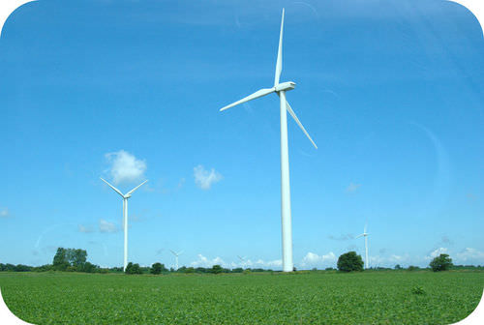

Wind is a renewable resource. Wind turbines like this one harness just a tiny fraction of wind energy.

Living things are considered to be renewable. This is because they can reproduce to replace themselves. However, they can be over-used or misused to the point of extinction. To be truly renewable, they must be used sustainably. **Sustainable use** is the use of resources in a way that meets the needs of the present and also preserves the resources for future generations.

### Non-renewable Resources

**Non-renewable resources** are [natural resources](http://www.ck12.org/biology/Natural-Resources) that exist in fixed amounts and can be used up. Examples include fossil fuels such as petroleum, coal, and natural gas. These fuels formed from the remains of plants over hundreds of millions of years. We are using them up far faster than they could ever be replaced. At current rates of use, petroleum will be used up in just a few decades and coal in less than 300 years. [Nuclear power](http://www.ck12.org/earth-science/Nuclear-Power) is also considered to be a non-renewable resource because it uses up uranium, which will sooner or later run out. It also produces harmful wastes that are difficult to dispose of safely.

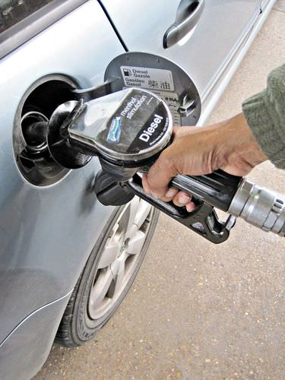

Gasoline is made from crude oil. The crude oil pumped out of the ground is a black liquid called petroleum, which is a non-renewable resource.

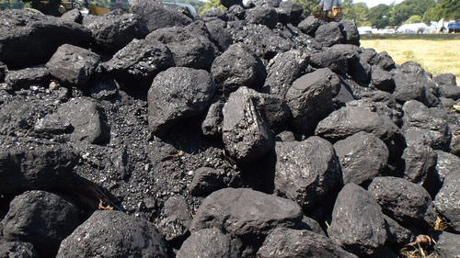

Coal is another non-renewable resource.

One environmental issue that has been of prominent concern in the 20th century has been the growth in human population. The chart below, from the population reference bureau, illustrates the dramatic growth in human population beginning around the year 1750. As human population has grown the demand for resources of all kinds has also grown. Supporting more people means producing more food, which in turn requires greater amounts of energy, soil nutrients, water, and other resources associated with agricultural production

There are many types of resources that go into producing food and producing forages. In general these resources have been grouped into two types: renewable resources and non-renewable resources. Renewable resources may be defined as resources that have the potential to be replaced over time by natural processes. The renewal process may be relatively quick, as with sunshine which comes on a daily basis. Or, the renewal process may be very slow, as in the formation of soil which may take hundreds of years. Non-renewable resources may be defined as resources whose stock or reserves is limited or fixed. The available supply of non-renewable resources may be replenished through recycling (e.g. recycling aluminium cans), but the overall supply remains relatively constant. The table below gives several examples of each type of resource.

|  |  |
| --- | --- |
| Renewable Resources | Non-renewable resources |
| Solar Energy | Oil |
| Soil | Steel |
| Trees | Aluminium |
| Grass | Coal |
| Groundwater | Phosphates |

Examining the resources listed in the table above suggests that modern agricultural production, including forage production, is dependent on a number of resources that are considered non-renewable. Farm equipment contains steel and aluminium parts and uses oil based fuels. The energy to manufacture fertilizer and other agrichemicals is derived from oil, coal, and natural gas. Phosphate fertilizers are widely used on crops. The realization of this dependence on non-renewable resources has led to increased interest in developing and implementing so called sustainable agricultural production systems.